Business Requirements Document (BRD)

- Login Module

1. Functional Requirements: Login Module
The Authentication system serves as the gateway to the platform, ensuring secure access and directing users to their specific workspace based on their profile.

1.1 UI Specifications: Login Page
The landing page shall serve as the primary authentication interface.
- Branding Elements: Display of official Company Logo and Slogan.
- Messaging: A clear "Sign In" header and a "Welcome" message.
- Input Fields:
  - Username/Email Text Box
  - Password Text Box (Masked)
- Action Elements:
  - Login Button: To authenticate credentials.
  - Sign-Up Button: To redirect to account creation.

1.2 Authentication Logic & Redirects
Upon clicking the Login button, the system must validate the credentials against the database:
- Role-Based Access Control (RBAC): Users must be redirected to their respective dashboards (Customer, Builder, or Consultant) based on their account type.
- Success Feedback: A "Welcome" notification popup must trigger upon successful authentication.

2. Functional Requirements: Registration Module
- The registration process captures essential user data to establish a profile within the system.

2.1 UI Specifications: Create Account Page
- The page shall include the following data entry fields:
- Role Selection: Dropdown or Radio selection (Customer, Builder, Consultant).
- Personal Information: First Name, Last Name.
- Contact Information: Email Address, Contact Number.
- Credentials: Username, Password.
- Submission: "Sign Up" button to finalize the process.

2.2 Post-Registration Workflow
- Data Validation: Ensure all mandatory fields are populated.
- Redirection: Upon successful submission, the system must redirect the user back to the Login Page.
- Confirmation: A notification popup shall appear stating: “Account Created! Your account has been created successfully. Please login to continue.”

3. UI/UX Standards: Notification Popups
All system-generated notifications (Success/Error) must adhere to the following behavioural logic:
Feature | Requirement
Error Message | Display: "✕ Login Failed. Invalid credentials. Please check your username/email and password."
Auto-Dismiss | Popups should auto-close after a set duration.
Hover Logic | If a user hovers the cursor over a popup, the auto-close timer must pause ("Stay Put").
Dismissal | Popups must disappear once the cursor is removed OR if the user clicks the manual "Close" button.

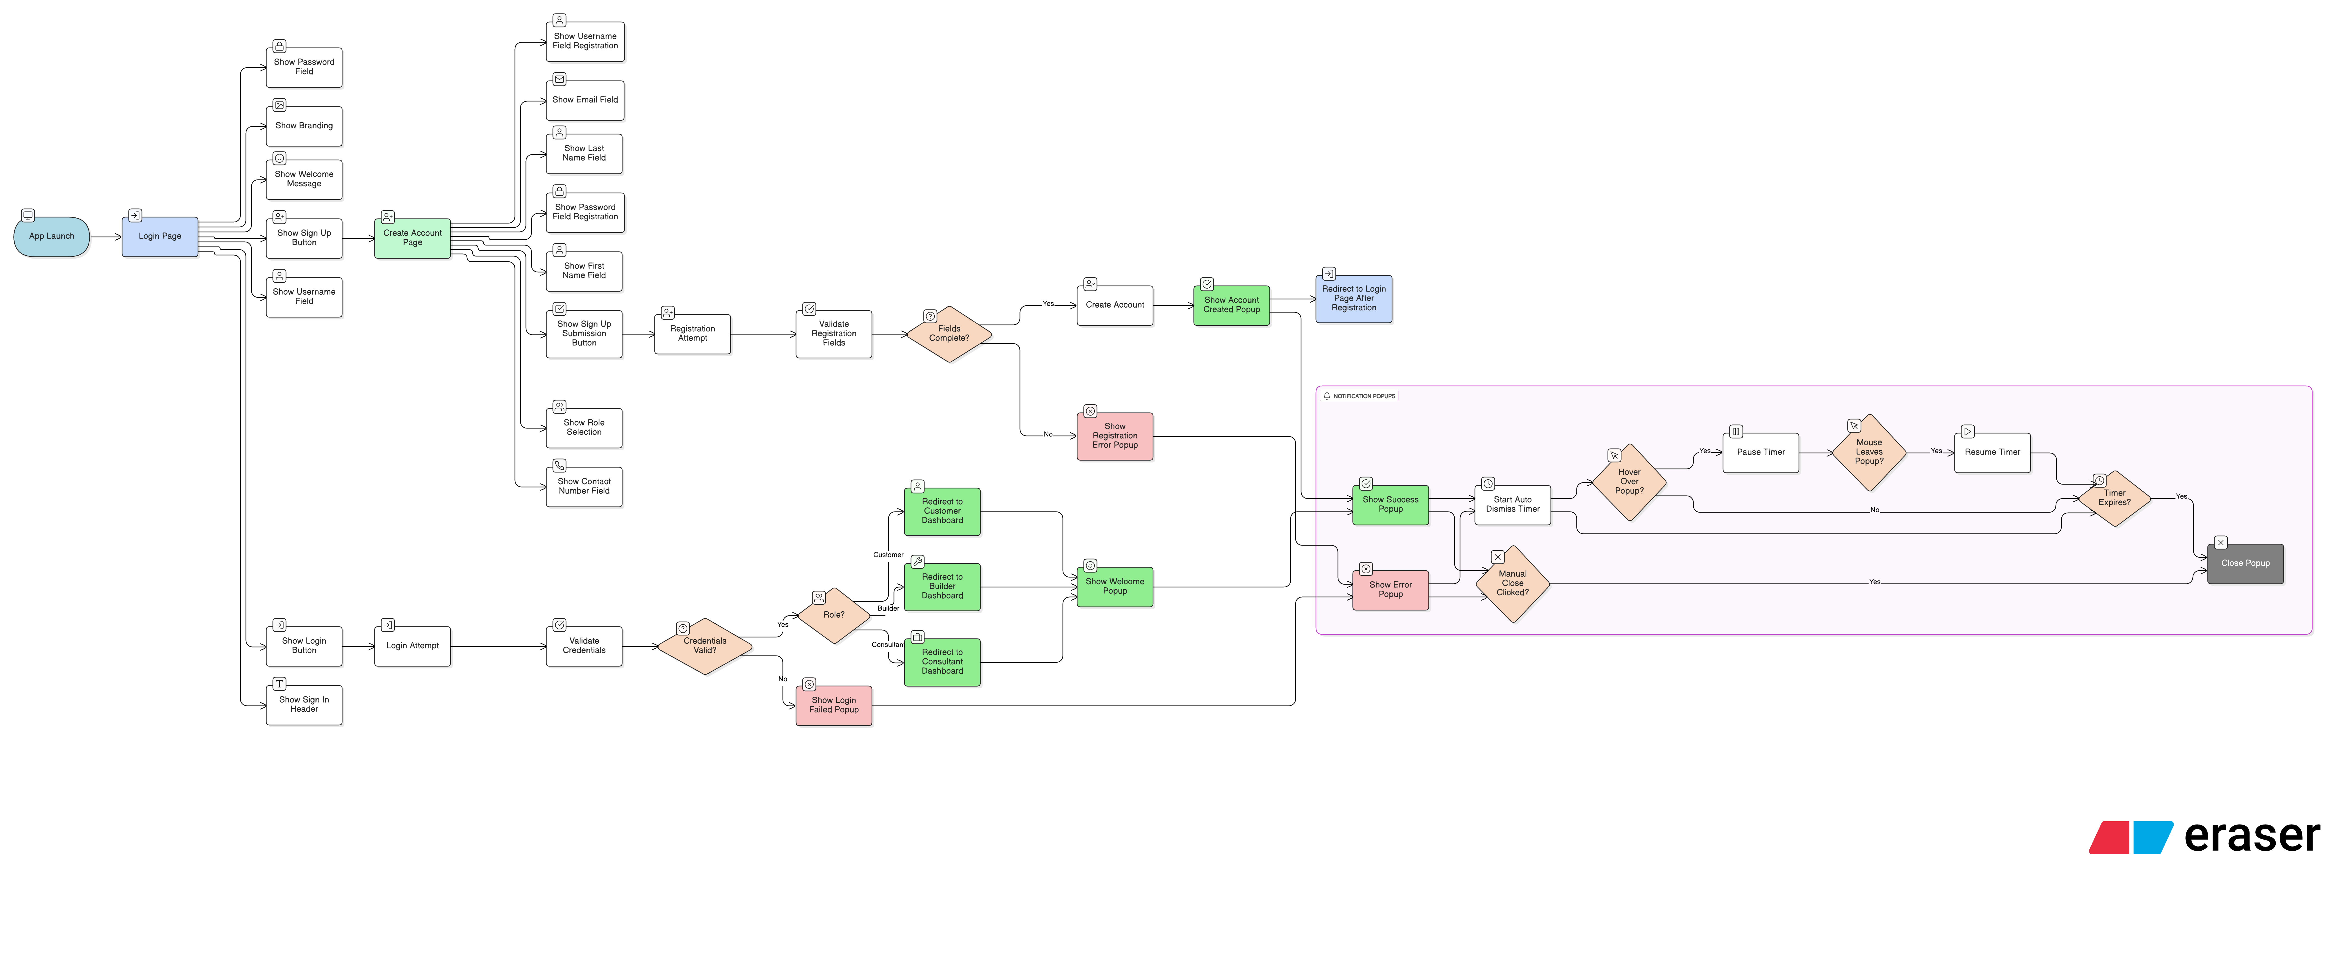

- Customer Dashboard & Profile Management

Following the established structure, this section details the post-authentication experience for users with the "Customer" role, specifically focusing on the Global Header and the Account Management module.

1. Functional Requirements: Customer Dashboard Header
The Header serves as the primary navigation and identity anchor for the user session.

1.1 Header UI Specifications
The header must remain persistent across all customer-facing pages and contain:
- Brand Identity: Real-Estate Partner logo (non-clickable).
- Personalized Greeting: Text display "Welcome [First Name] [Last Name]!" (Non-clickable).
- Identity Asset: Profile thumbnail displaying initials of the First and Last Name by default.
- Session Control: "Log out" button (Primary action).

1.2 Profile Dropdown Menu
Clicking the Profile thumbnail shall trigger a contextual dropdown menu containing:
- Identity Header: Displays full User Name (Non-clickable).
- Manage Profile: Redirects to the Profile Management page.
- Settings: Placeholder link (Page pending development).
- Logout: Terminates the session and redirects to the Login Window.

2. Functional Requirements: Manage Profile Page
The Manage Profile page provides a centralized interface for identity and security management, organized into four distinct functional blocks.

2.1 Block 1: Profile Identity & Media
- Media Management: Features a large thumbnail with initials. Includes an Edit option to:
  - Upload: Select a new image from the local device.
  - Delete: Revert to default initials.
- Adjustment Tool: Upon selection of a new image, an "Adjust Profile Picture" popup must trigger, allowing users to zoom and reposition the crop area.
- Identity Display: * Full Name in bold.
  - User Role: "Customer".
  - System Attribute: "Member since [Date]" (e.g., 30th December, 2025).

2.2 Block 2: Personal Information
Includes the following editable fields to manage contact data:
- Editable Fields: First Name, Last Name, Email Address, Phone Number.
- Read-Only Field: Username (Modification restricted).
- Action Elements: "Save Changes" and "Reset" buttons located at the footer of the block.

2.3 Block 3: Security (Change Password)
Provides a workflow for credential updates:
- Input Fields: Current Password, New Password, Confirm New Password.
- Action Element: "Update Password" button.

2.4 Block 4: Account Statistics
A dashboard summary widget displaying user activity metrics.
- Tracked Metrics: Favourites, Visits, Requests, and Total.
- Note: Calculation logic and data sourcing for these metrics are currently TBD (To Be Defined).

3. UI/UX Standards: Dashboard Interactions
Feature | Requirement
Logout Logic | Clicking "Logout" (Header or Menu) must clear session data and redirect to the Login Window.
Media Popup | The "Adjust Profile Picture" popup must follow the Hover/Auto-close logic defined in Section 3 of the previous module.
Field Validation | Real-time validation for email format and Phone Number length in the Personal Information block.

